**Computer Programming 1  
Essential Standard 7.03 Apply Built-in Math Class Functions  
Essential Standard 7.04 Apply Built-in String Functions   
Programming Exercise**

In all programs, put your name, the assignment name and the date in comments at the top.  
Reminder, put an apostrophe (‘) in front of your line to make it a comment.

1. Create a project called MathFun. Add the controls shown on the form below. Name appropriately.  
   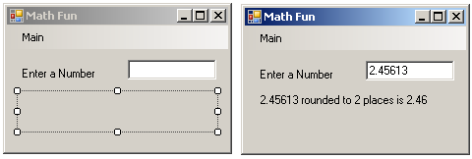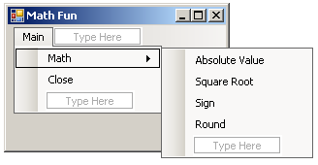
   1. Using the example in the PowerPoint, add the code to find the absolute value, square root, sign and rounded number of the number from the textbox.
      1. Use an InputBox to get the number of places for the rounding.
2. Create a project called MyName. Add the controls shown on the form below. Name appropriately.  
   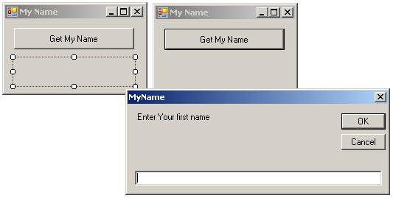
   1. Use InputBoxes to get your first, then your last name (Two separate InputBoxes)
   2. Use the Trim() function to remove any spaces.
   3. Use the .Concat function to merge the name together with a space between and display in the label.
3. Create a project called MyInitials. Add the controls shown on the form below. Name appropriately.  
   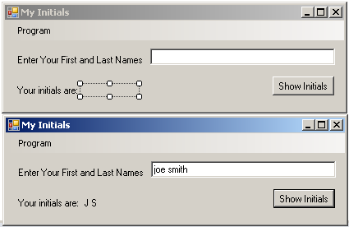
   1. Use the .Chars method to get the first initial.
   2. Use the .IndexOf method to find the position of the “ “, then use the .Chars method to get your last initial.
   3. Uppercase the initials and display them in the label.
   4. Add a close option to the Program menu to exit your application.
4. Create a project called WhichIsFirst. Add the controls shown on the form below. Name appropriately.  
   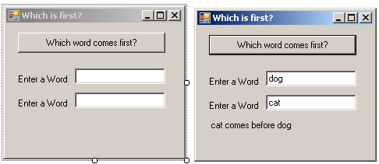
   1. Get the input, then use the Compare method to see which word comes first alphabetically.
      1. See the PowerPoint for hints.
   2. Display in the label.
5. Create a project called NewWord. Add the controls shown on the form below. Name appropriately.  
   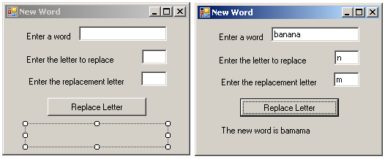
   1. Get the input, and then use the Replace method to replace the letters in the word.
   2. Display in the label.
6. Create a project called RemoveWord. Add the controls shown on the form below. Name appropriately.  
   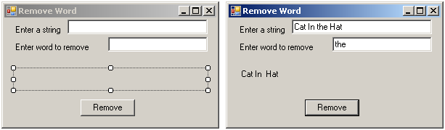
   1. Get the input, and then use the Remove method to replace the letters in the word.
      1. Hint: You will need to use the IndexOf method to find the location of the string to remove and the Length property to find how many letters to remove.
   2. Display in the label.